

207 E. MAIN STREET

LOWELL MI 49331

(616) 897-7200

Aprilfits207@gmail.com

PLEASE MAKE CHECKS PAYABLE TO FANS IN THE STANDS.

**Please submit order form and payment to Coach Drake**

**CONTACT Coach Drake for questions.**

LOWELL BOYS VOLLEYBALL FAN GEAR ORDER FORM

ALL ORDERS DUE: MARCH 29, 2019

|  |  |  |  |  |  |  |  |  |  |  |  |
| --- | --- | --- | --- | --- | --- | --- | --- | --- | --- | --- | --- |
|  |  |  | | | | **ADD $2.00** | | |  |  |  |
| **ITEM**  **DESCRIPTION** | **COLOR** | **S** | **M** | **L** | **XL** | **2XL**  **ADD** | **3XL** | **4XL** | **QTY** | **UNIT PRICE** | TOTAL PRICE |
| **EXAMPLE**  **LADIES TSHIRT** | **BLACK/GREY** |  | **X** |  |  |  |  |  | **1** | **$25** | **$25** |
|  |  |  |  |  |  |  |  |  |  |  |  |
|  |  |  |  |  |  |  |  |  |  |  |  |
|  |  |  |  |  |  |  |  |  |  |  |  |
|  |  |  |  |  |  |  |  |  |  |  |  |
|  |  |  |  |  |  |  |  |  |  |  |  |
|  |  |  |  |  |  |  |  |  |  |  |  |
|  |  |  |  |  |  |  |  |  |  |  |  |
|  |  |  |  |  |  |  |  |  |  |  |  |
|  |  |  |  |  |  |  |  |  |  |  |  |
|  |  |  |  |  |  |  |  |  |  |  |  |
|  |  |  |  |  |  |  |  |  |  | **TOTAL AMT.** | $ |

|  |  |  |  |
| --- | --- | --- | --- |
| NAME |  |  | **LOGO**  C:\Users\Fits-front\Documents\LACROSSE ORDER FORM PICS\VOLLEY ORDER\LHS BOYS VOLLEYBALL 2019.jpg |
| ADDRESS |  |  |
| CITY,STATE,ZIP |  |  |
| PHONE |  |  |
| PAID WITH CHECK NO. | |  |
| PAID WITH CASH | |  |
| COMMENTS: | |  |

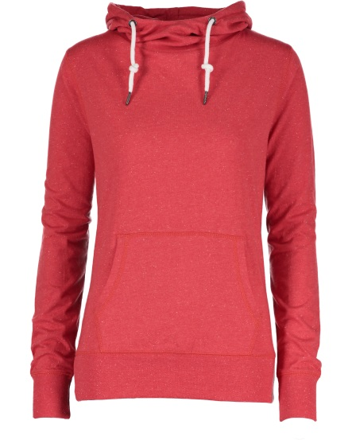 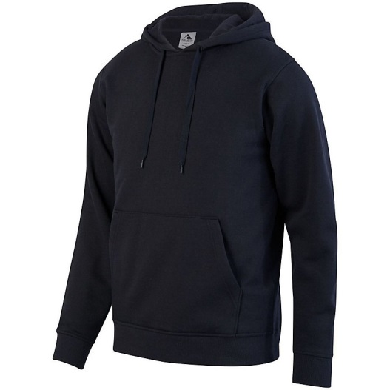

**$35 UNISEX HOODIE** #5415

(BLACK, RED, OR GREY)

S-5XL

**$30 LADIES FUNNEL NECK TEE**

#EZ091

(RED) S-4XL

**VOLLEYBALL FAN GEAR APPAREL**

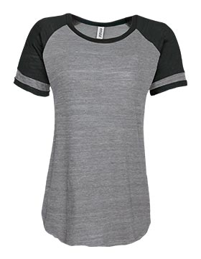 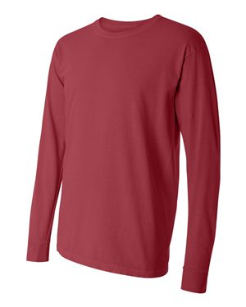 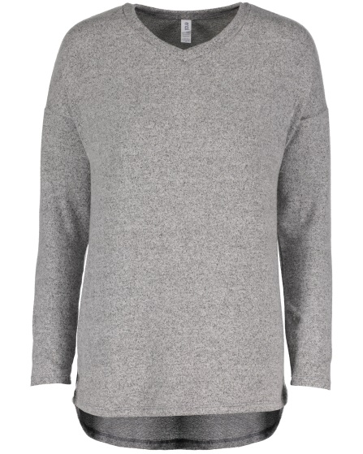 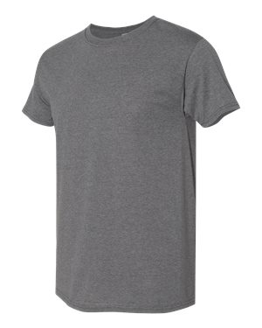

**$20 MEN’S TRIBLEND TSHIRT**

#JZ199

(CHARCOAL OR HEATHER BLACK)

S-3XL

**$22 UNISEX LONG SLEEVE TSHIRT**

#6014

(RED, BLACK, OR GREY)

S-4XL

**$25 LADIES TSHIRT** #EZ076

(BLACK/GREY ) S-4XL

**$32 LADIES SOFT V-NECK**

#EZ205

(GREY OR BLACK) S-4XL

DESIGN #1

**$80 MENS JACKET**

(BLACK **ONLY**) #229157

**Logo Embroidery ONLY**

DESIGN #2

**$ 40**

**LADIES SWEATSHIRT**

**(GREY / BLACK)**

#EZ383 OneStop

**$20 Unisex T-Shirt**

**50/50 COTTON**

**(RED / BLACK)**

#GD182 OneStop